**Review of the Cisco Catalyst 9200 Series**

Every wired device, such as a printer and computer, is connected to each other via an Ethernet switch. Cisco has introduced the Catalyst 9200 Series switches, which provide the exceptional capabilities you need to target the midmarket while double performance. It's the progression of the industry's most well-organized switches (Catalyst 2960X). The Catalyst 9200 Series provides 'Simplicity without Compromise' with customizable management choices such as DNA centre, Web UI, 3rd party tools such as Ansible playbook, and security and resilience.

In the IT sector, having a dependable and secure network configuration is critical not just for generating a return on investment, but also for ensuring that client goods are delivered consistently and safely. What we enjoy about the Catalyst 9200 Configuration Guide is that it allows us to network over the internet while maintaining network security and stability.

The Catalyst 9200 runs on the same OS (Operating System) as the other 9000 models, but is designed for smaller installations. The new switch gives mid-market businesses access to Cisco's whole suite of business services without sacrificing the security afforded by enterprise switches. The 9200 Series is designed to provide convenience without compromising security or IT efficiency. It is always on, secure, and expands IT productivity.

**Features:**

The current Cisco Catalyst 9200 series has the following characteristics and benefits.

* Secure

The switches feature Trustworthy solutions, MACsec encryption, Talos, and segmentation for best-in-class security. You'll also receive powerful security measures that protect the integrity of your software, hardware, and any data that passes through the switch. ​​

* IT Simplicity

Get a basic Cisco DNA or online UI provisioning, as well as Cisco XE's open APIs (Application Programming Interface) and ASIC UADP technology's programmability. Cisco series 9200 switches are easy to use and provide investment protection for future innovations.

* Resilient

Catalyst 9200 switches provide business-level flexibility, including FRU (Field-Replaceable Unit) power supply and fans, cold patching, modular uplinks, and PoE (Perpetual Power over Ethernet).

* Cloud Ready

Convert your cloud settings in a safe, straightforward, and efficient manner. Cisco provides a digital-ready approach that starts at the border and works its way down to the app level.

**Always On**

* Your system will always be available at your request with the highest MTBF (Mean time between failure).
* Cold patching keeps the switches up-to-date and secure without having to reload the image.
* Even in the restart of a switch, perpetual resiliency provides power for devices

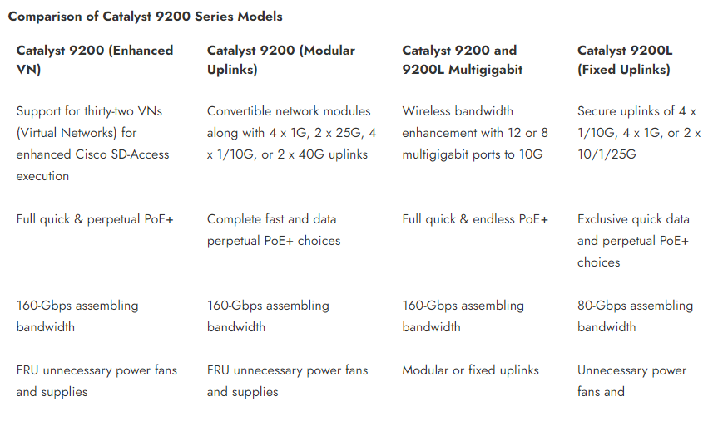

**Conclusive Thoughts:**

The newest Catalyst 9200 Cisco series is guaranteed to please customers that enjoy full-featured, cost-effective Cisco 2960-X Catalyst switches. The 9200 Series enhances simplicity and availability by utilising a dependable design that makes network operations safer and faster. The Cisco Catalyst 9200 is an excellent choice for customers looking for increased uplink and bandwidth capabilities while also anticipating their company's future needs. If you want to learn more about the Cisco series, visit [Subserve.co.uk](https://subserve.co.uk/).